Alaska to Pennsylvania
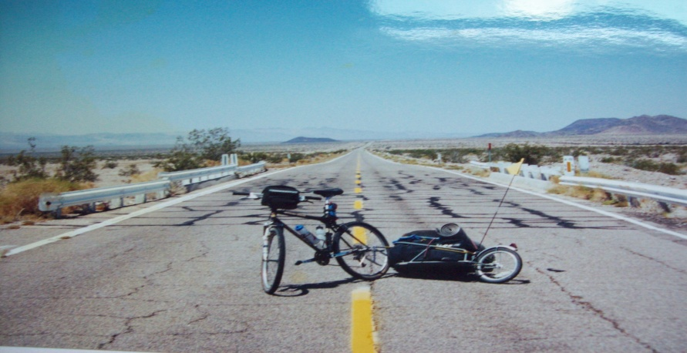 Bicycle Ride 1999
20th Anniversary
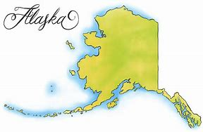
Come hear the epic story of this 7,150 mile journey
Who: Justin Zimmerman
Where: Bowmansville Mennonite Church
129 Pleasant Valley Rd, East Earl, PA 17519
When: October 26th, 2pm – 4:30pm and 6pm – 8:30pm
Cost: Free Will Donation to Benefit
-“TNT” Youth Ministries
-Nathan, Magaly & Jacob Sensenig serving with “Smiles with Hope” in Costa Rica

